Clinical Director Invitation Template - Fit Feet Program
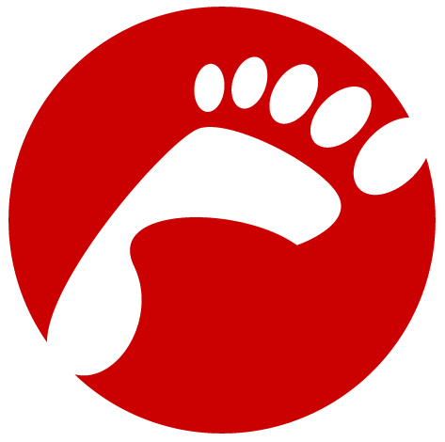
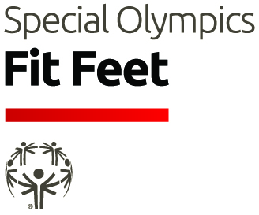
Dear INSERT NAME/ORGANIZATION
Special Olympics is the world's largest sports organization for children and adults with intellectual disabilities, providing year-round training and competitions to more than 4.5 million athletes in 170 countries. Special Olympics competitions are held every day, all around the world—including local, national and regional competitions, adding up to more than 90,000 events a year. Special Olympics is the largest global public health organization dedicated to serving people with intellectual disabilities. The Special Olympics Healthy Athletes Program offers health screenings in seven areas: Fit Feet-podiatry, FUNfitness- physical therapy, Health Promotion- better health, nutrition and well-being, Healthy Hearing- audiology, MedFest -sports physical exam, Opening Eyes- vision and Special Smiles- dentistry.
Fit Feet helps Special Olympics athletes step lively on the playing field, and in everyday life. Many athletes suffer from foot and ankle pain, or deformities that impair their performance. In fact, up to 50 percent of Special Olympics athletes experience one or more preventable or treatable foot conditions that can affect their sports participation. Often, these individuals are not wearing the most appropriate shoes and socks for their particular sport. To alleviate these problems, volunteer foot specialists work with athletes to evaluate problems of the feet, ankles and lower extremity biomechanics.
Special Olympics needs volunteer health care professionals to serve as Clinical Directors for its Healthy Athletes Fit Feet Program. Special Olympics is reaching out to Foot Care Specialists. As a Fit Feet Clinical Director you will join other health professionals volunteering in the Special Olympics Healthy Athletes Program. To learn more about Special Olympics Fit Feet, please visit www.specialolympics.org/fitfeet.
Special Olympics is recruiting for Fit Feet Clinical Directors for several state and country programs. Please contact one of the individuals listed below to discuss how you can join our team and make a difference in a Special Olympics athlete’s life.
Meggin van der Hilst: Senior Manager, Special Olympics Fit Feet - E-mail: mvanderhilst@specialolympics.org
Dave Jenkins: Fit Feet Global Clinical Advisor - E-mail: djenki@midwestern.edu

Clinical Director Invitation Template - Healthy Athletes Program

Dear INSERT NAME/ORGANIZATION
Special Olympics is the world's largest sports organization for children and adults with intellectual disabilities, providing year-round training and competitions to more than 4.5 million athletes in 170 countries. Special Olympics competitions are held every day, all around the world—including local, national and regional competitions, adding up to more than 90,000 events a year. Special Olympics, as the largest global public health organization dedicated to serving people with intellectual disabilities, needs volunteer health care professionals to serve as Clinical Directors for its Healthy Athletes program. The specialized backgrounds and expertise you offer can ensure that the Healthy Athletes program helps change the lives of people with intellectual disabilities.

Officially launched in 1997, Healthy Athletes organizes its health events in a welcoming, fun environment. Its events educate athletes on healthy lifestyle choices and identify problems that may need additional follow-up. There are seven disciplines in Healthy Athletes. Information and resources are available for each on the Special Olympics website.


Fit Feet offers podiatric screenings to evaluate ankles, feet, lower extremity biomechanics, and proper shoe and sock gear to participating athletes.

FUNFitness is the physical therapy component of Healthy Athletes. Designed to assess and improve an athlete’s flexibility, functional strength, aerobic capacity and balance. These screenings also educate participants, families and coaches.

Health Promotion uses health screenings, interactive educational tools and displays, motivational literature and demonstrations to heighten the awareness of athletes, reinforcing the need to improve and maintain an enhanced level of wellness and self-care. It also provides screening for BMI, blood pressure, and bone density.

Healthy Hearing offers a free hearing screening designed to ensure proper audiology care for Special Olympics athletes.
MedFest offers a sports physical exam for athletes, needed prior to participating in Special Olympics sports programming.


Opening Eyes The Special Olympics-Lions Clubs International Opening Eyes program provides a vision and eye health screening in partnership with the Lions Clubs International Foundation. Led by volunteer vision care professionals, Opening Eyes offers prescription eyewear, sunglasses, and sports goggles to Special Olympics athletes.
Special Smiles provides comprehensive oral health care information, including free dental screenings and instruction on correct brushing and flossing techniques to participating Special Olympics athletes. This also includes issuing preventative supplies like toothpaste and toothbrushes and fluoride varnish.

To learn more about Special Olympics Healthy Athletes, please visit
http://www.specialolympics.org/healthy_athletes.aspx?source=navbar.

Please accept our invitation to empower our athletes by promoting healthy behaviors and lifestyles and serving as a Clinical Director. As one Healthy Athlete volunteer recently said, "The athletes thank me for what I do for them, but it is really the athletes who deserve my thanks for what they do for me.”

Special Olympics is recruiting for Clinical Directors in all disciplines for several state and country Programs. Please contact your local Special Olympics Program to discuss how you can join the Healthy Athletes team and make a difference in a Special Olympics athlete’s life. A list of local Programs is available at: http://www.specialolympics.org/program_locator.aspx

Volunteer Recruitment Letter – Healthy Athletes

Join us on <EVENT DATE AND TIME> and Volunteer with the Special Olympics <name of program> Healthy Athletes Program

Special Olympics is currently recruiting volunteers for upcoming health screening events in several health areas. We hope that you can contribute your time and skills to the movement and help change the lives of people with intellectual disabilities in your community through our Healthy Athletes Program.

Special Olympics is the world's largest sports organization for children and adults with intellectual disabilities, providing year-round training and competitions to more than 4.5 million athletes in 170 countries. Special Olympics competitions are held every day, all around the world—including local, national and regional competitions, adding up to more than 94,000 events a year.

Special Olympics, is also the largest global public health organization dedicated to serving people with intellectual disabilities. The Special Olympics Healthy Athletes Program offers health screenings in seven health disciplines:
Fit Feet offers podiatric screenings to evaluate ankles, feet, lower extremity biomechanics, and proper shoe and sock gear to participating athletes.
FUNFitness is the physical therapy component of Healthy Athletes. Designed to assess and improve an athlete’s flexibility, functional strength, aerobic capacity and balance. These screenings also educate participants, families and coaches about fitness and how to improve each component of fitness.
Health Promotion uses health screenings in BMI, blood pressure, and bone density, interactive educational tools and displays, motivational literature and demonstrations to heighten the awareness of athletes, reinforcing the need to improve and maintain an enhanced level of wellness and self-care.
Healthy Hearing offers a free hearing screening designed to ensure proper audiology care for Special Olympics athletes.
MedFest offers a sports physical exam for athletes, needed prior to participating in Special Olympics sports programming.
Opening Eyes The Special Olympics-Lions Clubs International Opening Eyes program is a vision and eye health screening in partnership with the Lions Clubs International Foundation. Led by volunteer vision and eye care professionals. Opening Eyes is able to offer prescription eyewear, sunglasses, and sports goggles to Special Olympics athletes.
Special Smiles provides comprehensive oral health care information, including free dental screenings and instruction on correct brushing and flossing techniques to participating Special Olympics athletes. This also includes issuing preventative supplies like toothpaste and toothbrushes and fluoride varnish.

Additional information and resources are available for each health discipline on the Special Olympics website http://www.specialolympics.org/healthy_athletes.aspx
We would like to invite volunteers with clinical and public health backgrounds, as well as all other interested volunteers who may not have clinical or health experience..
The opportunity to volunteer with Special Olympics is truly a rewarding one: As one Healthy Athletes volunteer recently said, "The athletes thank me for what I do for them, but it is really the athletes who deserve my thanks for what they do for me!”
If you are interested in volunteering with the Special Olympics Healthy Athlete team and learning more about the specific disciplines and upcoming volunteer opportunities, Please contact the following individual at your local program by <DATE>:

<SPECIAL OLYMPICS PROGRAM>
<HEALTHY ATHLETES COORDINATOR/EVENT COORDINATOR>
<EMAIL ADDRESS/PHONE NUMBER>

